Professional Association Executive Board
September 14, 2023, Meeting Minutes

Present: Norma Chrisman, Alison Doughtie, Aaron Fried, Patti Antanavige, Robin Saxe, Christine Van Namee, Erica Brindisi, Justin Rahn, Ross Wittenberg
Excused: Kelly McNamara, Michael Kuczynski, Yue Riesbeck
Item | Discussion | Action/Decision
Call to Order and Approve Agenda | Meeting was called to order by President Norma Chrisman | Call to order at 3:10
Approve of Minutes | Approval of May 9, 2023, minutes | Motion: Robin Saxe  Second: Ross Wittenberg  Motion approved
President: | - United Way Board of Director meeting (05/25, 07/20)  - CNY Labor Council meeting (05/25)  - Job description meetings (5/30, 06/07, 06/14,06/30, 07/18,08/18),08/23,09/12)  - Board of Trustee meeting (06/20)  - Meeting with College and Gilroy, Kernan, Gilroy (06/22)  - James R Cook Agency and CNY Labor Council meetings (06/22)  - VOTE COPE Election report submitted (07/17)  - Member issue meeting with Patti (08/01, 08/02, 08/08, 08/14, 08/15)  - Meeting with President VanWagoner (08/14)  - Member issue (08/24)  - James R Cook Labor Agency meeting (08/28)
Correspondence: | Thank you notes from:  - Team Rocco LaBella  - Kathy Kotary -Relay for Life Survival Gifts  - Ted Moore Run Walk  - Abraham House  - Anita’s Stevens Swan Humane Society  - MVCC Foundation Golf Tournament

Treasurer’s Report | Membership  - We currently have 217 paying members.  - New paying members:  - Dylan Blier  - Beth Dubeck  - Qamar Fahmi  - Chelli Kaufman  - Rachel Maiolo  - Kathleen Montague  - Kenny Stover  c. Non-paying members:  - Jonathan Boardman (NEW)  - Abbie Bohling (NEW)  - Stephen Warzala (NEW)  - Gabrielle Coffey  - Sara Cutright  - Harlan Fuller  - Caitlyn Graham  - Christopher Hanrahan  - Lori Hughes  - Scott Jackson  - Nicole Law  - Jessica Norris  - Frank Vellone  - There may be newer employees that we don’t know about. If you know someone new and aren’t sure if they’ve completed an enrollment form, you can ask me if they’re a member.  2. Beginning of Semester Info!  - If you need reimbursement for an amount paid related to your committee, please let me know. There is a spreadsheet for you to complete to help me categorize the expenditure.  - Please submit an itemized receipt/invoice with the expenditure spreadsheet.  - Stipends are paid to Executive Board members and committee chairs three times per year. (Most people receive a stipend only once or twice per year.)  - If you receive a stipend, you may receive a tax form 1099-NEC in January. If your address changes, please let me know so that I complete the tax forms correctly.  3. Audit  - The PA Audit Committee performed an audit of our 2022-23 financial results in early June. They found no material weaknesses with the financial information and had no recommendations.  - Audit report and financial statements were sent to AFT in June.  4. Bank Balance & Reconciliation  a. The bank statement has been reconciled through August 2023.  b. The current checkbook balance is $247,213.48.  c. Actual budget lines represent: May 1, 2023 - Today  Remaining budget lines represent: Today - April 30, 2024  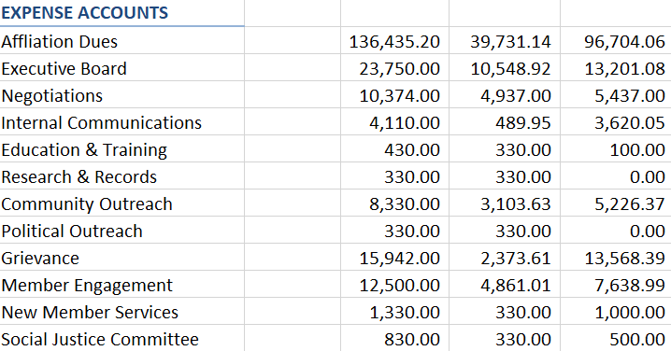
Committee Reports
Benefits Fund | - Our Legal and Davis Vision plans were renewed. Great news – 2% decrease in our annual premium!  - Christine answered numerous benefit questions over the summer. Many of the questions could be answered via the Benefits Fund FAQ Guide. Christine will work making the necessary updates and will provide to the membership.  - Christine will work with Ross to get signatures updated on Benefit Fund and PA bank accounts.
Community Outreach | - Kathy Kotary is working with Rome Grassroots Committee for their Trick or Treat event. The PA will have a table set up at the event and hand out candy.  - Robin has been in contact with Kernan Elementary School to arrange the delivery of the donated school supplies  - NYSUT Fall Leadership Conference Making Strides Fundraiser  - Raffle tickets received to sell for the event  - Basket to be donated  - NYSUT Community College Conference  - Basket to be donated | Motion to approve $150 to purchase candy for the event by Aaron Fried  Second: Patti Antanavige  Motion approved  Motion to approve $100 to provide basket for the event by Aaron Fried  Second: Ross Wittenberg  Motion approved  Motion to approve $100 to provide basket for the event by Aaron Fried  Second: Justin Rahn  Motion approved
Education and Training | - The committee is scheduled to meet on Sept 26 and will brainstorm ideas for what the committee should do this year.
Internal Communications | - Expect to publish PAnorama mid October – articvles should be submitted to Robin by October 3rd  - She will solicit articles from her committee members
Member Engagement | - Fall Luncheon was held where promotion, appointment, and years of service gifts given to members  - Around 90 members signed up for the event but only 70 attended  - Erica sent American Dining a letter expressing our concerns and dissatisfaction with the food setup time and various food items/service. American Dining provided a discount for the event and offered a sincere apology.
Political Outreach | - Participated in the CNY Labor Council Endorsement process  - The group endorsed various candidates but opted not to endorse a candidate for Utica Mayor as some unions are endorsing one candidate whereas others are endorsing a different candidate.
Research and Records | - No report
New Members | - Discussion regarding date for New Member reception  - The group determined that Nov 8th would best fit everyone’s schedules
Grievance | - No report!
Negotiations | - The group convened to review the survey results and also reviewed 12 month professional job descriptions. We review grades, preferred qualifications, and minimum qualifications.
Social Justice | - Committee is meeting today and will be discussing homelessness concerns.  - Discussion around organizing faculty, staff and students to volunteer as food servers at a local soup kitchen  - Hosting a panel discussion about the topic
Old Business | - No report
New Business | - No report
Next Meeting | The next meeting October 12 2023 3pm PH391
Adjourn | Motion to Adjourn: Robin Saxe  2nd: Justin Rahn | Adjourned at 4:00 pm

