Professional Association Executive Board
May 9, 2023, Meeting Minutes

Present: Norma Chrisman, Alison Doughtie, Aaron Fried, Patti Antanavige, Robin Saxe, Kelly McNamara, Kate Polivka, Sam McManus
Excused: Christine VanNamee, Erica Brindisi, Justin Rahn, Melissa Barlett, Ross Wittenberg
Item | Discussion | Action/Decision
Call to Order and Approve Agenda | Meeting was called to order by President Norma Chrisman | Call to order at 3:03
Approve of Minutes | Approval of April 11, 2023, minutes | Motion: Aaron Fried  Second: Patti Antanavige  Motion Approved
President: | - Board of Trustee meeting (04/17)  - Meeting with HR Executive Director Marceau regarding position change (04/18)  -Norma went with Patti A. regarding a change in position at the college for a member  - Meeting with HR Executive Director Marceau and VPLAA Kahler regarding budget (04/18)  -went back in the afternoon with Patti A. and Aaron F. regarding review of retrenchment procedures  - ED39 and Community College planning conference meetings (04/20)  -Will be in Saratoga Springs again in early November 2023  - Meeting with HR Executive Director Marceau regarding NTP grade assignments (04/20)  -looking into finding guidelines for NTP grade assignments  - CNY Labor Council Workers Memorial Day event (04/24)  -Norma attended at the Workers Memorial in Ilion followed by a dinner and proclamations given by Oneida County Executive Picente
Correspondence: | - MVCC Foundation – thank you note for Ted Moore sponsorship
Treasurer’s Report | 1. Membership  - We currently have 217 paying members.  - No new paying members.  c. Non-paying members:  - Gabrielle Coffey  - Sara Cutright  - Harlan Fuller  - Caitlyn Graham  - Christopher Hanrahan – confirmed does not want to be a member  - Lori Hughes - confirmed does not want to be a member  - Scott Jackson  - Nicole Law  - Matthew Maloy - confirmed does not want to be a member  - Kenny Stover  - Frank Vellone  - There may be newer employees that we don’t know about. If you know someone new and aren’t sure if they’ve completed an enrollment form, you can ask Ross if they’re a member.  2. May Stipends  - Stipends have been paid to e-board members, committee chairs, and negotiations team members. (These are pretty much the only expenditures that you see on the financial summary on the next page.)  3. Audit  - The audit of our 2022-23 financial results will take place at the beginning of the fall semester or during the summer, based on the audit committee’s preference. (This is still in time with AFT requirements.)  4. Bank Balance & Reconciliation  a. The bank statement has been reconciled through March 2023.  B. Actual budget lines represent: May 1, 2023 - Today  Remaining budget lines represent: Today - April 30, 2024 (new fiscal year!)  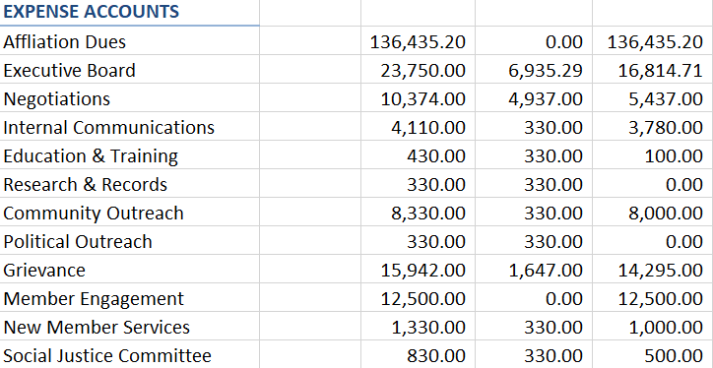
Committee Reports
Benefits Fund | - I received the Group Legal Contract renewal from NYSUT on 4/29/23. Our NYSUT Member benefits Trust -endorsed Group Access Legal Service Plan expired on 4/30/23 and will be renewed with no changes for the next year. The new rate-guarantee period began on 5/1/23. The annual per participant fee will remain at $35.  - I received our benefits usage report for the period of 1/1/22-3/31/23 on 5/3/23. I planned to forward this report to the trustees once I receive confirmation of the official renewal of our contract with NYSUT. I conferred with Justin Wilcox as previous Chair and he confirmed that he found usage to be decent. Trustees should be on the lookout for further communication within the week.
Community Outreach | - Spoke with Anita’s Steven Swann Humane Society regarding the Spring Fling donations. I will share their wish list and how to make cash donations. There will also be opportunities to work with the dogs.  - Basket for Celebration of Success is ready  - Keychains for the Relay for Life will be sponsored by the PA. $184 for 100 Keychains.  - Robin Saxe, Erica Brindisi and Christine Miller represented the PA at the RA. We won The Community Service Award from NYSUT | Motion: Aaron Fried  2nd: Patti Antanavige  Motion Approved.
Education and Training | - No report
Internal Communications | - See ballot information below.
Member Engagement | - PA Spring Fling is Monday, 5/15/23 at Tavolo’s form 5pm-8pm  - We have reserved AC 116 on 8/23/23 for the fall luncheon from 11am – 2pm
Political Outreach | - State budget passed  -100% base funding floor using the 2022-2023 fiscal year, so even if we have an enrollment decline for the upcoming fall 2023 and/or spring 2024 semesters we still get the same amount of money from the state.  -$75 million in funds set aside for “non-reoccurring transformation initiatives”  - SUNY and CUNY trustees will be directed to develop a long-term plan to address the impact of student enrollment fluctuations on the academic and financial sustainability of their respective campuses  - Getting ready for the 2023 Oneida County Board of Legislature endorsement process, as we’re in an election year fo the County and all seats are up for election.
Research and Records | - No report
New Members | - No report
Grievance | - No report
Negotiations | - In addition to the Grade level review, we are almost ready to send out a survey to members for negotiations, it will be out before the end of obligation
Social Justice | - Met earlier today regarding the workshop we will be hosting to discuss with members what our Committee is doing for the Union
Old Business
New Business | - Election results – appointments  - Motion to approve ballot | Motion: Patti Antanavige  2nd: Aaron Fried  Motion approved
Next Meeting | The next meeting TBA in September 2023
Adjourn | Motion to Adjourn: Aaron Fried  2nd: Patti Antanavige | Adjourned at 3:41pm

